Web Help Desk

# Abstract

The web help desk is a tool intended to provide the employee or end user with support and services related to the company. The purpose of the web help desk is simplifying the working environments and improving the communication between the service requester and the service provider. The web help desk effectively performs several functions such as managing the employee and departments and all that will be explained in this document.

Table of Contents

Acknowledgements 2

Abstract 3

Chapter 1: Introduction 6

1.1 Problem Statement 7

1.2 Goals of the system 7

1.3 Objectives of the system 8

1.4 Solution 9

1.5 Project Scope 9

1.6 Project Plan 10

Chapter 2: Literature Review 11

2.1 Odoo Software 11

2.2 Zoho Desk Software 13

Chapter 3: System Analysis 16

3.1 Functional Requirements 16

3.2 Non-Functional Requirements 18

Chapter 4: System Design 19

4.1 System use-cases: 19

4.2 Admin use-cases: 20

4.3 Manager use-cases: 21

4.4 Employee use-cases: 22

4.5 Service Requester use-cases: 23

4.6 Database ER Diagram: 24

4.7 Database Entity: 25

4.8 Database Constraints: 26

4.9 Class diagram: 27

4.10 Page Structure: 28

4.11 State Diagram: 30

4.12 User Interface Prototype: 31

Chapter 5: Conclusion 36

References 37

**Table of Figures**

Figure 1: Odoo Software: Creating new department [1] 11

Figure 2: Odoo Software: Department’s page [1] 12

Figure 3: Related work: Creating new employee [1] 12

Figure 4: Zoho Desk; Received Ticket [2] 14

Figure 5: Zoho Desk: Ticket Design [2] 14

Figure 6: Admin use-case 20

Figure 7: Manager use-case 21

Figure 8: Employee use-case 22

Figure 9: Service requester use-case 23

Figure 10: Database ER Diagram 24

Figure 11: Class Diagram 27

Figure 12: Page Structure for the Admin 28

Figure 13: Page Structure for the Manager 28

Figure 14: Page Structure for the Employee 29

Figure 15: State diagram for manager requesting task 30

Figure 16: Log-in Sample Design 31

Figure 17: Add Task Sample Design 32

Figure 18: Ticket Sample Design 33

Figure 19: Creating Department Sample Design 34

Figure 20: Registering Employee Sample Design 35

## Problem Statement

The project will solve many problems that company and organization facing such us the difficulty of communicating and requesting service from department to another, the difficulty that faced the head of department in controlling the employees, with this software the employees can request help easier with the ticketing system method, the employee can send a help ticket to a specific department and receive help faster and easier, also the head of department can give task to employee and monitor the employee easier, and all the tickets and the tasks will be saved and documented to use it for improving the work efficiency and to rate the employees.

## Goals of the system

The project will benefit and help the organization to keep track of the efficiency of the employees. It also can improve the communication between the employees and the managers. And it will provide balance among the employees regarding the tasks distributed. The system will provide a function that will track the tasks that been distributed to let the managers know who is doing their tasks in time and who is slacking with their tasks.

## Objectives of the system

Objectives:

1. Improve the employee’s workplace experience
2. The system will offer 2 types of tasks [Manually assigned, auto assigned]
3. The employees can see all their tasks from the system.
4. Managers can distribute tasks to the employees using the system.
5. Distribution of the tasks will be documented in the database.
6. Employees can see the tasks from the system and when they finish, they can submit and add notes.
7. Employees can request services and the request will go to manager of the department.
8. Managers can see the efficiency of the employees from the stored documentation and from the task rating.
9. The task and ticket assignment will have a deadline and the employee should solve the assignment before the deadline.
10. The system will send notifications and alerts about the status of the assignments to the service requester and the service provider.
11. The system will send reminder notification to the service provider about the assignments.

## Solution

With this software, the admin has the ability to add the departments to the system in addition to the ability to assign Head of departments and employees The organization hierarchy (departments) will be represented in the system. Whereas the service demander such as students, faculty member, or any other employee will have a specific interface in, they can file a ticket and follow up on its progress, they can also get a notification when the ticket is closed, and they can evaluate the provided service. The head of the department will have an interface and will be able to manually assign tasks to one or more employees, check the status, get statistics, and get alerts for late tasks. The employee of any department will have a specific interface, the employee will have the ability to see the assigned tasks, get all the details needed on this ticket and its requester, in addition to that the employee has the ability to comment then close the ticket and see the requesters evaluation on of the ticket and when it comes to the requests a ticket will be automatically assigned to a specified employee in a specific department.

## Project Scope

Web Help Desk is a web application for organization and companies. Which can help managers to assign and review task and the employee can accept and submit the task. Manager and employee also can request a service from specific department.

# Chapter 2: Literature Review

## Odoo Software

Odoo software [1] has some similar feature to our project idea, this software main goal is to help and give features to the organization to manage the employees. This software mainly focusing on HR department and how happy the employee of the organization and implementing a strategy to improve employee satisfaction. However, we will focus on some feature that meet our needs only. Such as that the admin can create new department with simple steps as following, and he can enter new employee to the new departments and manage many things, as shown below.

**Database – Creating new department,** Administration can create new department in few second and register employee under the department easily.

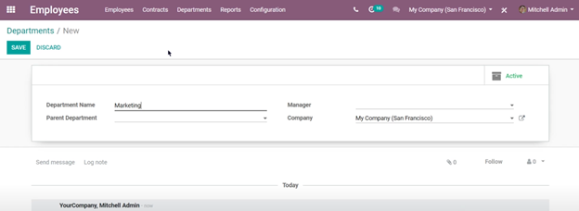

Figure 1: Odoo Software: Creating new department [1]

**Database – Department’s page**, All the departments that has been created by the administration will be in this page, each department have their employees registered inside and the manager can interact with employees for each department.

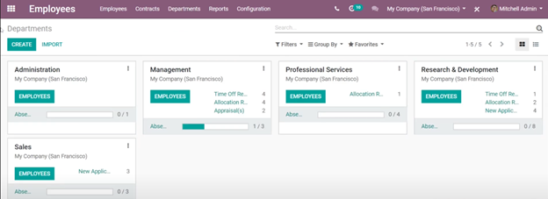

Figure 2: Odoo Software: Department’s page [1]

**Database – Creating new employee,** Administration can create new employee and assign him under a department.

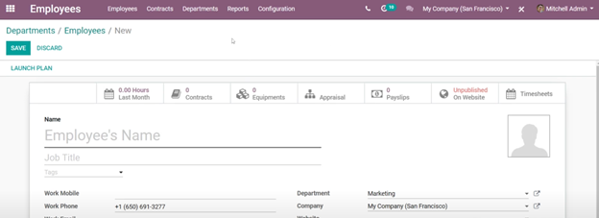

Figure 3: Related work: Creating new employee [1]

**With these features, we can implement to our project the following:**

1. The admin can create a department [Figure ] and can create a new employee [Figure ] to the organization and assign him to a specific department.
2. The head of the department can manually assign task to the employee under the department or can direct tickets that came from other department employee, or he can set the ticket automatic equally assigned to each employee. Also, the head of the department can review and rate the employee based on their work in solving the tickets or the task.
3. HR department can oversee all important information and all the rates about employee that came from the head of department for each department and employee.

## Zoho Desk Software

Zoho Desk software [3] has some familiarity with our idea based on the ticket procedures that the software use, this software mainly focuses on customer care operators to keep track of user requests and deal with customer care related issues. This software mainly uses the ticket to solve the issues that arise to the customers.

**Ticket –** Here in this page the employee can see all the ticket that has been send from customers.

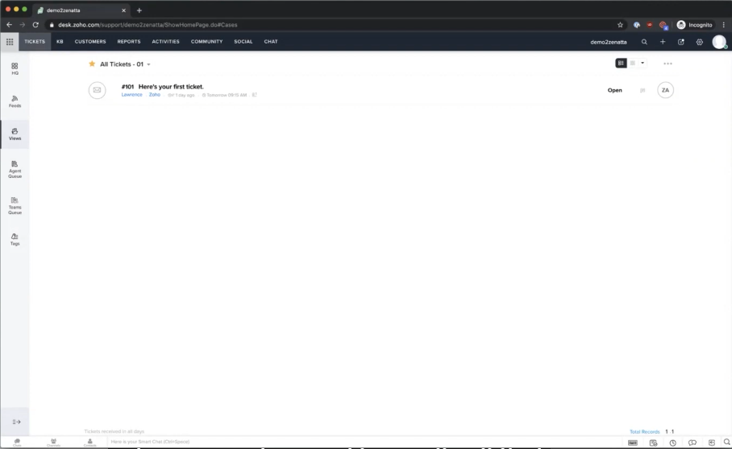

Figure 4: Zoho Desk; Received Ticket [2]

**Ticket –** This is the ticket interface it is very simple and similar to emails.

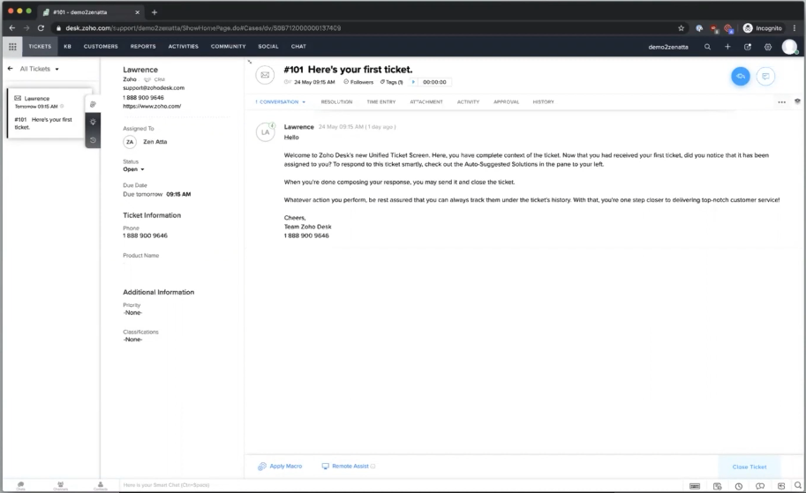

Figure 5: Zoho Desk: Ticket Design [2]

**With these features, we can implement to our project the following:**

1. The employees can receive a ticket from other department employee to get help on issues arise inside the departments. [Figure ]

With this feature solving any problem arise in the organization will be easier and faster.

1. The head of the department can review and monitor all the tickets and how employee is solving the tickets. With this feature the productivity of the department will increase since all the work of the employee is documented and can be monitor easier.
2. HR department can oversee all information and all the comments that came from the head of department, and they can monitor the employees easier.

**List for other similar help desk software:**

1. LiveAgent
2. ProProfs Help Desk
3. HaloITSM
4. Gorgias
5. OneDesk
6. Jitbit Helpdesk
7. ServiceDesk
8. EngageBay

# Chapter 3: System Analysis

## Functional Requirements

Functional and Non-Functional requirements [4] are product features that we must implement to achieve user's tasks and goals.

**Functional requirements for admin:**

1. The admin shall be able to login to the system
2. The admin shall be able to logout from the system
3. The admin shall be able to create employee profile
4. The admin shall be able to create manager profile
5. The admin shall be able to update employee profile
6. The admin shall be able to update manager profile
7. The admin shall be able to reassign manager to departments
8. The admin shall be able to reassign employees to departments
9. The admin shall be able to create departments
10. The admin shall be able to organize the departments
11. The admin shall be able to remove departments
12. The admin shall be able to view all the users of the system
13. The admin shall be able to check the task status
14. The admin shall be able to update task status
15. The admin shall be able to archive task
16. The admin shall be able to get the statistics
17. The admin shall be able to get notification about tasks
18. The admin shall be able to reset the password for employee
19. The admin shall be able to reset the password for manager

**Functional requirements for manager:**

1. The manager shall be able to login to the system
2. The manager shall be able to logout from the system
3. The manager shall be able to assign tasks to employees
4. The manager shall be able to check the tasks status
5. The manager shall be able to get the statistics
6. The manager shall be able to get notification for late task

**Functional requirements for employee:**

1. The employee shall be able to login to the system
2. The employee shall be able to logout from the system
3. The employee shall be able to accept the assigned task
4. The employee shall be able to view the assigned task
5. The employees shall be able to comment on the requested task
6. The employee shall be able to submit the task
7. The employee shall be able to upload files
8. The employee shall be able to view the requester evaluation

**Functional requirements for service requester:**

1. The service requester shall be able to login to the system
2. The service requester shall be able to logout from the system
3. The service requester shall be able to request a service
4. The service requester shall be able to view current / old requests
5. The service requester shall be able to view details of specific request
6. The service requester shall be able to re-open closed request
7. The service requester shall be able to send feedbacks/evaluation for closed request

**Functional requirements for the system:**

1. The system shall be able to archive all the tickets and tasks done by the employees.
2. The system shall send notifications to the service requester about their tickets status.
3. The system shall mark new tasks or ticket received with blue circle to notify the employee.
4. The system shall mark the task and ticket has been solved with green circle.
5. The system shall mark the task and ticket that has been reviewed from the manager and reopened for further assistance with orange circle to notify the employee.
6. The system shall mark the task and ticket that has been overtimed and not solved with red circle.

## Non-Functional Requirements

1. The system shall be accessible by users who are authorized and registered by the administration only.
2. Passwords on the database shall be stored as hashed to ensure security.
3. Passwords shall never be viewable at the point of entry or at any other time.
4. The system shall not be shut down for maintenance more than once in a 24-hour period.
5. The system shall be compatible with Windows, IOS, and Linux operating system.

# Chapter 4: System Design

## System use-cases:

The admin will have the ability to organize and assign the organization's hierarchy and give access to other users to their interfaces and some other features if needed. The service requesters interface gives them the ability to review and follow up the progress of the ticket and get notified, addition to that the service requester can also evaluate the service or the ticket when the manager enters his or her interface, he or she can view their options such as manually assigning the tasks of the employees in addition to that they can also review the status of the ticket and check its statistics. The manager can also evaluate the employees by entering the page of the task of a specific employee of a department and read through the comments of the service requester to see their satisfaction and evaluate the employees based on it. lastly, the employee can access his or her interface and can view their assigned task and can also see all the details needed on the page of the given task (ticket) In addition to that, all the evaluations will be sent to the HR department to see the evaluation, and the HR manager can also evaluate and monitor the employees, and also all evaluations will be stored in the system.

The users of this system are:

1. Admin
2. Employee
3. Manager
4. Service Requester

## Admin use-cases:

Figure 6: Admin use-case

## Manager use-cases:

Figure 7: Manager use-case

## Employee use-cases:

Figure 8: Employee use-case

## Service Requester use-cases:

Figure 9: Service requester use-case

## Database ER Diagram:

The Database ER Diagram of the system:

Figure 10: Database ER Diagram

## Database Entity:

1. **User:**

u_id: It is the primary key, and it is auto increment

username: It is the username, and it cannot be null, should be unique for each user, the type is varchar, and the size is 20

email: not null, should be unique for each user, the type is varchar, and the size is 255

passwords: not null, the type is varchar, and the size is 255

is_a: it is either an employee, a manager, or an admin. To show the proper interface when the user logs in.

1. **Assignment(Ticket/Task):**

a_id: it is the primary key; it is auto increment.

req_u_id and rec_u_id: Is a foreigner key. It is connected to u_id in the user table.

description: it is the description of the ticket or the task the user enters the type is varchar and the size is 512.

date: it is the date of the ticket, or the task could not be null it takes date and time.

status: it is the status of the ticket, or the task and it takes one of the following values 0 , 1 , 2 and 3. 0 means initiated. 1 is progress. 2 is done and 3 is approved.

feedback: it is the feedback by the manager, and it can be either approved of rejected.

rate: it is the rate of the task or the ticket and takes one of the following values 0, 1, 2 ,3 and 4. 0 means poor 1 means not good 2 means ok 3 means good 4 means excellent

type: it is the type of the assignment takes one of the following value 0 or 1. 0 means task and 1 means ticket.

1. **Department:**

d_id: it is the primary key; it is auto increment.

d_name: it is the department name, and it cannot be null, should be unique for each department, the type is varchar, and the size is 20

d_head: It is the manager or the head of the department.

1. **Employee:**

em_id: it is the primary key, and it is auto increment

name: it is the employee’s name, and it cannot be null, the type is varchar, and the size is 40

phone: it is the phone number of the employee it cannot be null; the type is varchar, and the size is 10

salary: is it the salary of the employee and it cannot be null, and it takes int value.

year_exp: It is the date the employee joined the company, so we can calculate how many years and experience the employee got, it cannot be null, and it takes date value.

dop: It is the day of birth of the employee it cannot be null, and it takes date value.

Job_title: It is the job title of the employee, and the type is varchar, and the size is 20.

## Database Constraints:

1. The requester of service in ticket table should not be the same person who is doing the service.
2. The requester of the task should not be the same person who is doing the task.
3. In table user, the column is_a takes one of the following four values:

0, 1, 2 or 3. 0 means the user is an admin. 1 is a manger, 2 employee and 3 is a service requester.

## Class diagram:

## The class diagram of the system

Figure 11: Class Diagram

## Page Structure:

Page Structure for the Admin:

This page structure describes the admins interface and its included pages

such as the home page will have subpages departments and employees.

Figure 12: Page Structure for the Admin

Page Structure for the Manager:

This page structure describes the managers interface and its included pages.

The home page will have subpages such as employees ,tasks, tickets, and statistics.

Figure 13: Page Structure for the Manager

Page Structure for the Employee:

This page structure describes the employees’ interface and its included pages. The home page will have subpages such as tasks and tickets.

Figure 14: Page Structure for the Employee

## State Diagram:

State Diagram of the manager requesting a task:

Figure 15: State diagram for manager requesting task

## User Interface Prototype:

Figure 16: Log-in Sample Design

Figure 17: Add Task Sample Design

Figure 18: Ticket Sample Design

Figure 19: Creating Department Sample Design

Figure 20: Registering Employee Sample Design

# Chapter 5: Conclusion

The goal of the project to develop a web application that will make the communication in the organization easier and better between the employees and managers and departments. Sometimes the employee and managers might face difficulties requesting services or communicating between departments. This problem can have impact to the employee and managers performance and satisfaction. With our project the managers now can assign task, check status, get statistics and request services. In addition, the employee can accept the task and start working then submit it. Also, the employee and managers can request services from specific department in the organization by submitting a ticket and the employees of that department can solve it. After the ticket and tasks has been solved the manager can rate the service provider and employee performance. In conclusion, we believe that our project can create a better working environment in the organization, and it will make the work more efficient.